NORLOG
INSTRUCTIONS FOR THE (TOP) OF WINDSOR TREE SEAT.
PLEASE READ BEFORE YOU START YOUR BUILD.
CONTENTS
15 Whole Logs
3 Packs Reducing Logs
3 Half Top Logs
Fixing Pack

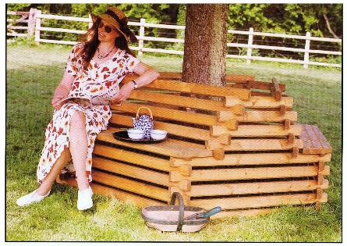

Please note this is a natural wood product and some components will have the odd blemish or knott.
Once you have completed assembling base section of your seat, continue your build.
- Offer 3 of the whole logs parallel to the seat parts (fig 1), notch numbers upward facing, running in a clockwise direction. 1, 2, 3, 4, 5, 6
- Offer the 3 longest of the reducing logs to the whole logs that are running parallel with the seats, notch numbers upward facing (fig 3). 1, 2, 3, 4, 5, 6
- Make sure the top and bottom cut-outs are in line before interlocking them into each other.
Tap one way or the other to line them up.
- Continue this until all whole and reducing logs are used.
- Now finish with the three half logs notch number facing each other, fix the three half logs with the wire nails supplied. (not shown in main picture, this is a new fitting for added strength.)
- You may wish to screw the top and bottom of your tree seat together using the six long screws provided. Fix through the first whole log you placed on to the lower seat part (fig1). This is your option, it will stay together without the screws.

Please enjoy your seat.

fig1 fig2 fig3 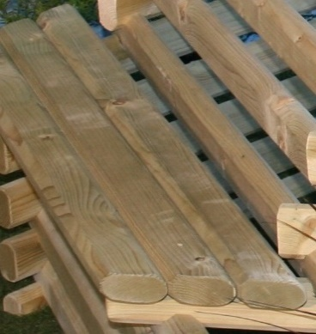 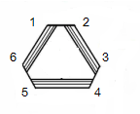 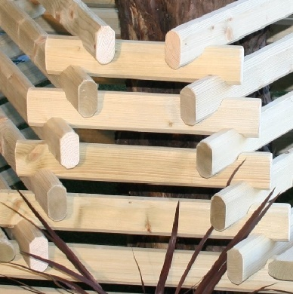
Seat
NORLOG UK Ltd. Unit 9N. Site A. Rednal Ind Est. Rednal. Oswestry. Shropshire.
www.norloguk.com

