NORLOG
CRYSTAL TREE SEAT
PLEASE READ BEFORE YOU START BUILD.
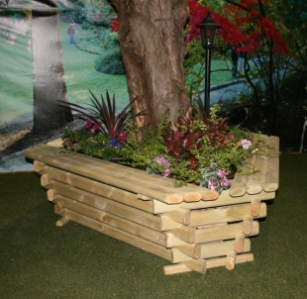
CONTENTS
12 Whole Logs
12 small logs
3 Bottom Half Logs
3 Seats + 6 Screws
60x60mm screws
Fabric liner

PLEASE NOTE SOME LOGS MAY BE BRUISED THIS IS DUE TO BEING ASSEMBLED FOR NUMBERING.
All numbers are upward facing and are the same number on top of each other they go in a clockwise direction.
- START WITH THE 3 HALF LOGS AROUND BASE OF YOUR TREE. fig1.
- NEXT 3 WHOLE LOGS (3 per row) TAP THE CUT-OUTS FIRMLY INTO EACH OTHER. (screw logs together via the pilot holes and 60mm screws)
- NEXT 3 SMALLER LOGS (3 per row). THEN 3 WHOLE LOGS THEN 3 SMALL LOGS UNTIL ALL 24 LOGS ARE USED. The small logs move up a size on each row. (fig 2) Screw each row together.
- Always make sure the cut-outs are firmly fixed in to each other before screwing together.
- WHEN ALL LOGS ARE USED, POSITION AND SCREW THE SEATS IN PLACE 6 screws. . (top log to top log) fig3.
- PLACE FABRIC LINER IN PLACE THEN FILL WITH SOIL. (We recommend you fix the seat to the ground with small stakes or similar if you do not fill with soil).

fig1 fig2 fig3
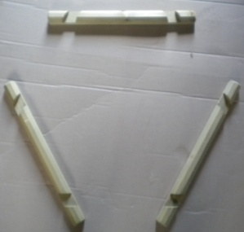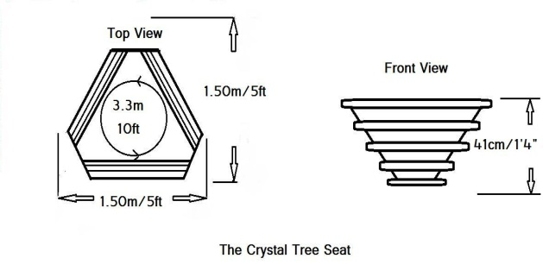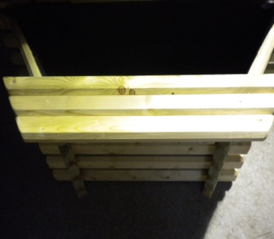
9 foot
max
NORLOG UK Ltd. Unit 9N. Site A. Rednal Ind Est. Rednal. Oswestry. Shropshire. SY11 4HS.
Tel/Fax: 01691 610000. Email: info@norlog-group.co.uk www.norloguk.com

