NORLOG
INSTRUCTIONS 400 GALLON POOL
PLEASE READ BEFORE YOU START BUILD.
CONTENTS
48 WHOLE LOGS
3 HALF LOGS
3 SEATS + 6 SCREWS
1 LINER + liner Protection
3 TIMBER BATTENS+PINS

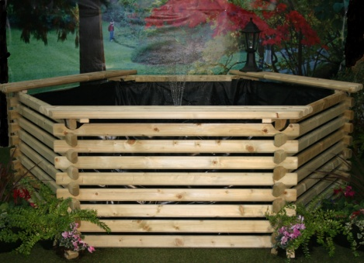

- FIND A CLEAN AND LEVEL AREA TO BUILD. MAKE SURE THERE ARE NO SHARP OBJECTS UNDER THE LINER AS THIS WILL CAUSE A PUNCTURE.
- WE RECOMMEND YOU HAVE 20mm OF SOFT SAND UNDER POOL AREA.
- START WITH 3 HALF LOGS. fig1.
- CONTINUE BUILD WITH WHOLE LOGS 3 PER ROW, PLACE ONE SIDE OF THE LOG TOGETHER FIRST THEN OFFER THE OTHER SIDE, CHECK TOP AND BOTTOM CUT OUTS ARE IN LINE, GENTLY TAP THE LOG ONE WAY OR THE OTHER TO GET THEM IN LINE BEFORE JOINING THE TOP AND BOTTOM LOGS. A RUBBER HAMMER OR WOOD MALLET IS THE BEST TOOL TO USE. fig2.
- WHEN ALL 48 LOGS ARE FIXED, PLACE FELT LINER PROTECTION OVER SAND BASE THEN OPEN SHAPED LINER INSIDE FRAME SPREAD IT OUT MATCHING FRAME SHAPE, HOOK LINER LOOPS OVER TOP 2 LOGS. fig3.
- FILL WITH WATER. THE 3 BATTENS AND PINS ARE TO HOLD LINER IN PLACE ONLY DO THIS WHEN THE POOL IS FULL.(fix to top 3 logs)
- SCREW THE SEATS IN PLACE TOP LOG TO TOP LOG. (Not on one log.) fig4

fig1 fig2 fig3 fig4
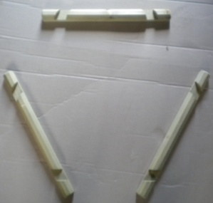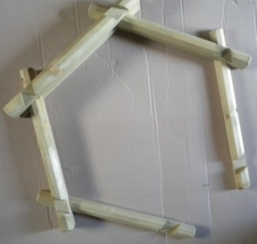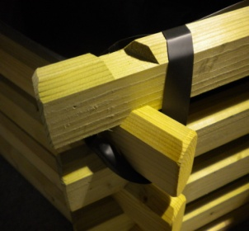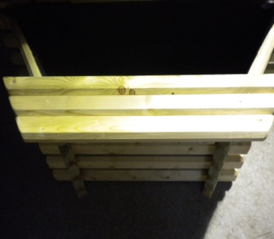
Norlog. Unit 9N Rednal Industrial Estate Queens Head Oswestry Shropshire SY11 4HS
Tel/Fax: 01691 610000. Email: info@norlog-group.co.uk
www.norloguk.com

